Jake Geddes & Olivia Besse
LONDON sPORTS TRUST
www.londonsportstrust.com
02087351589
Charity Number: 1077167
london Sports trust games manual
Table of Contents

Page 3-4: Introduction
Pages 5-12: Games
Page 13: Local sessions

Who are the London Sports Trust?
London Sports Trust (LST) started out as a small charity awarding bursaries to talented athletes through seed funding from the John Lyons charity in 1999. This tradition has continued with the David Robins trophy being awarded to one talented athlete a year. Most notably one of the first recipients of this award was Sir Bradley Wiggins. Twenty years later LST has since evolved into a multidimensional sporting charity that offers PE as well as community sport and play provisions to over 1700 people weekly. This is all in the aim of cultivating positive change that allows Londoners to achieve their sporting and educational goals.
The purpose of this manual?
The purpose of this manual is to give enthusiastic parents of children aged 2-11 the opportunity to learn new games that they can replicate at home with their child/children. The games have deliberately been chosen as they require very little equipment so they should be easy to repeat at home.
Why is play important?
Play allows children to develop creativity and imagination while developing physical, cognitive and emotional strengths. Play also enhances physical health by building active healthy bodies. This has subsequently led to extensive reports stating that physical activity beginning in early childhood prevents obesity.
Play is also essential to developing social and emotional ties between family members. This is because children’s healthy development is mediated by appropriate nurturing relationships with caregivers, (i.e., Parents, grandparents and older siblings). Play allows for a different yet powerful quality of interaction between parent and child. This can because when parents interact in child-driven play, they can observe the world through their child’s eyes and therefore may learn to communicate or offer guidance more effectively. Potentially SEN and Less-verbal children may be able to express themselves, including their frustrations through play. Above all, the intensive engagement and relaxed interactions that occur while playing tell children that their parents are fully paying attention to them and thereby contribute to a strong connection.
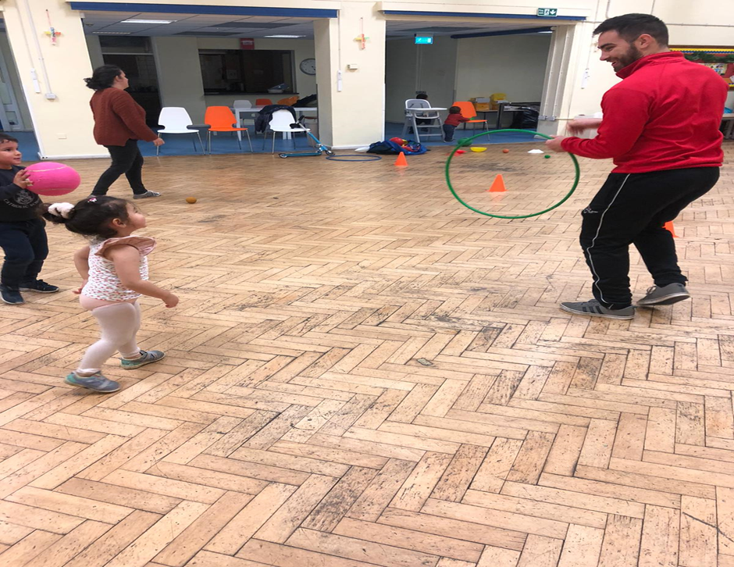

Game 1: Snake
Description:
The adult surrounds the area with cones or toys. The aim of the game is for the child to retrieve the cones/toys one at a time and build a wiggly line from one side of the room to the other in the shape of a snake.
Once achieved the child/children need to line up and walk over the top of the cones without touching them.
Equipment:
- Cones/toys
Progressions:
- Children can move across the snake in a mixture of ways e.g. jumping like a kangaroo, bear crawling, spider crawl, etc.
- Children can use their imagination and make other animals/ shapes with the cones.

Game 2: Coin Collector
Description:
Put all of the balls in a big bucket or bag then count with the children to 5 and release all the balls across the room. The children need to get one ball at a time and put/throw the balls back into the bin/bag. Make it fun by saying the bin is hungry and you need to feed it.
Equipment:
- Cones/toys/balls
- Bag/bin/bucket
Progressions:
- Hold the bin high so children need to jump and throw higher to get it in the bucket.
- Move with the bin so children have to run quicker.
- Set different colour cones on the outside of the bin depending on the colour of the ball the child runs to the corresponding cone and throws from there.
- Make a time limit to see if the child can retrieve all the items in a set time.
Game 3: Find the toys
Description:
The parent hides the toys around the playing area whist the child/children close their eyes and count to 10. Subsequently, the child tries to find the hidden toys and give them back to the parent.
Equipment:
- Cones/toys
Progressions:
- When the children retrieve the items they can move in different ways.
- Create a time limit so that the child has a set time to retrieve all the items.
- Swap the roles around so now the children hide the item.

Game 4: Spaceship
Description:
The parent or child steps into the hoop with two hands on the hoop as seen in the image below. Next the other person gently pulls and guides the other person around the playing area. If you do not have access to a hoop just hold hands instead.
Equipment:
- Hoop
Progressions:
- To progress, swap roles so the child gets the feel of being the driver and the rider.
- Now on the count of 10 pick up the child as if you were launching the spaceship.
- Now the driver closes their eyes and the rider has to give instructions so they do not crash and bump into anything.
- Set up an obstacle course where you need to navigate around in the spaceship.
Game 5: Rob the nest
Description:
To set up, put together a square full of toys. Then the parent and child stand on opposite sides of the room. On the shout of go both participants run out towards the pile of toys, picks up one item and returns it back to their area. The team that collects the most items after the allocated amount of time wins.
Equipment:
- Cones/toys/objects around the home
Progressions:
- To progress the adult encourages the child to move in a different ways (jumping, hopping, big steps, little steps, crawl etc.)
- Create a time limit to make it more competitive for the child – try and beat previous times.
- Introduce another person as a guard so that if you get tagged you need to drop the item and return back to base before you can have another go.

Game 6: Time Bomb
Description:
All participants get into a circle and play catch. If someone drops the ball, the person who dropped it must pick the ball up and tag anyone by touching him or her with the ball. The other players should run away in order to not be tagged. The parent counts down from 10 so the tagger gets 10 seconds to tag as many people as possible.
Remember - When tagging the other person, hands must always be in contact with the ball so try not to throw the ball to tag the other person, must touch them with the ball instead.
Equipment:
A ball (can also use a toy)
Progressions:
- Make the passes harder by standing further apart
- Throw high/low balls making it harder to catch
- Switch objects i.e. from a football to a tennis ball

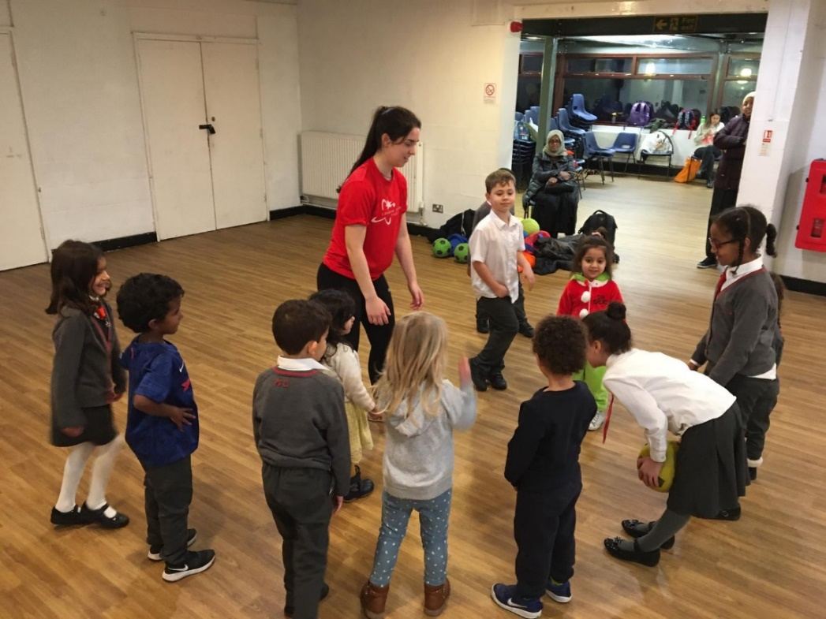

Game 7: Obstacle Course
Description:
Create a fun obstacle course in your home or any outdoor space. Remember - the key is to be as creative as possible when designing the obstacle course.
Equipment:
Anything around the house i.e. toys/balls/chairs/duvets or outside i.e. climbing frame in playground/stones/skipping ropes/hoops etc.
Progressions:
- Have the child carry a ball or toy or other object through the obstacle course to increase the challenge. Make it weighted to make it even harder.
- Have the children move like an animal all the way through the obstacle course i.e. crab walk, bear walk, crawling like a spider, snake, tiger etc
- Make it a speed challenge by timing them to see how quickly they can get through the obstacle course. Repeat this so child can try to beat their previous time.
- Keep changing the obstacle i.e. by adding objects to make it harder.
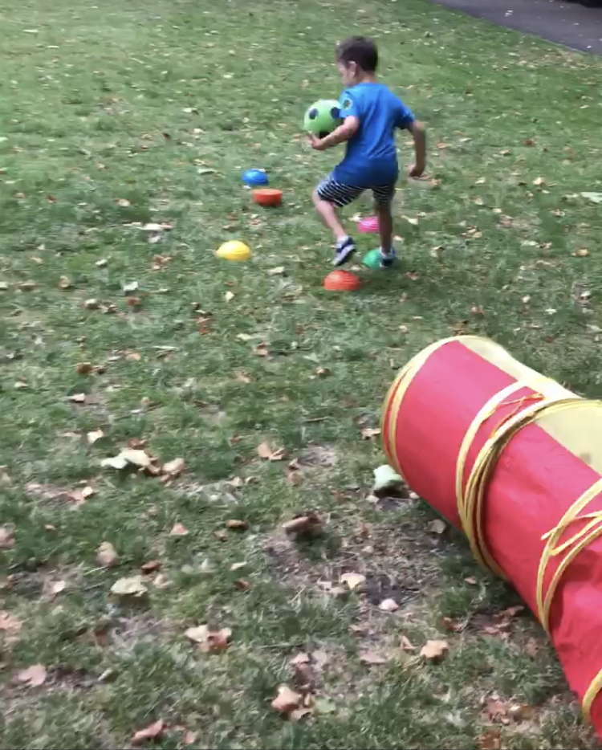

Game 8: Knock down the target
Description:
Child throws/rolls object to knock down a variety of targets. Each player gets a turn to choose 4 objects to act as targets, and one object to throw. Child tries to knock down all 4 targets in 10 throws. Then swap roles.

Equipment:
Anything around the house i.e. toys/balls/water bottle etc. or outside i.e. stones/trees/floor markings etc.
Progressions:
- Increase distance from targets
- Change the throwing object i.e. make it smaller
- Use non-dominant hand
- Change throwing style i.e. overhead rather than underhand
- Use an implement i.e. cricket bat to roll the ball forwards
- Place an obstacle in-between the throwing line and obstacle.
- To introduce an element of aim, the player who set up the targets identifies which target they want to challenge the other person to hit.

Free White city sessions

Activity | Location | Address | Age group | Times
Boxing session | Phoenix academy | The Curve, Shepherd's Bush, London W12 0RQ | 8-16 year olds | Monday 5-6
Family play sessions | Edward woods community centre | 60-70 Norland road  W11 4TX | Under 5s with their parents | Tuesdays 12-1
Football training session | Play football | 41 S Africa Rd, Shepherd's Bush, London W12 7RW | 8-16 year olds | Tuesday 5-6
Play sessions | Lady Fatima community centre | Commonwealth Ave, White City, London W12 7QR | 2-11 year olds | Wednesday 4:30-5:30
Football games session | Play football | 41 S Africa Rd, Shepherd's Bush, London W12 7RW | 8-16 year olds | Wednesday 6-7
Family play session | Molly Hut | Canada Way, White City, London W12 7PH | Under 5s with their parents | Friday  10:30-11:30
Play session | Phoenix academy | The Curve, Shepherd's Bush, London W12 0RQ | Children of all ages and parents | Saturday 10-11

